9 Exiting the Room
Now we have our maze and the doorways, next we need to be able to allow the hero to actually exit the maze and the room.

Creating a New Tile Map
We need to create another room to this maze for the hero to escape to. I want to make a few changes to this maze. Actually, I will be creating a new tile map. Our hero is 64 px, size. Mainly because it looks better at this size. My wall pieces are 32px, and they actually look better at this size. But I want this new room to have a grid that is 64px so it interacts better with the hero.
Go to Photoshop

Create your canvas size to be 1024 x 1024. Remember that we created the tile map for the 32px sprites, at the size of 512 x 512. We got this figure, by taking the size of the sprite 32px, and multiplying it by 16. Now since we are working with the tile set with sprites that are sized at 64 x 64, we want to multiply 64 x 16, and this will give us our size of 1024.
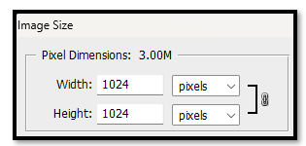

Set the grid line to be created 64px increments, on the canvas.
Edit-Preferences-Guide, Grid, Slices… Set this to be 64px.

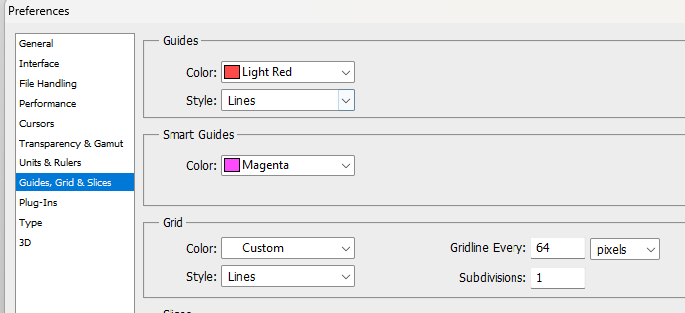
View-Show-Grid
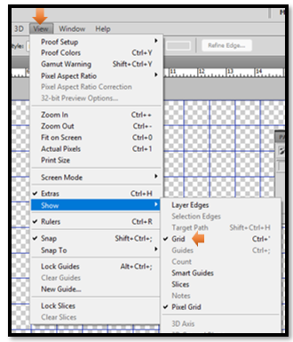
This is an image of the 4 floor sprites
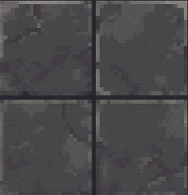
You want to separate these different floor tiles, and put them in the photoshop canvas.
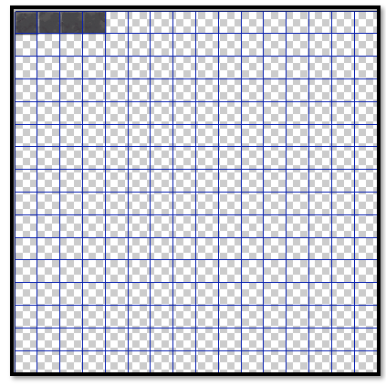
Turn this first into a sprite. Right click on the sprite file, and create a sprite for this new 64px tile set.
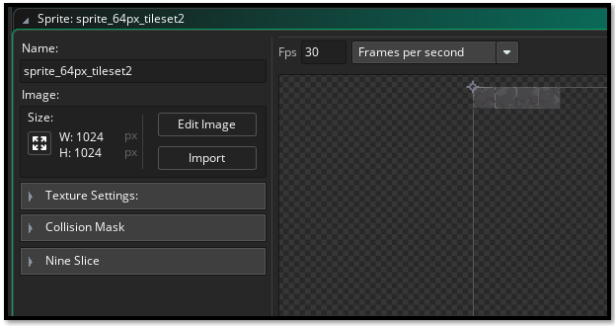

Create your tile set
Create your tile set. Right click on the tile Sets folder and create the tile set.
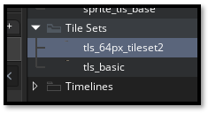
Notice that my tile set came in with multiply images for my 4 tiles of the walls.
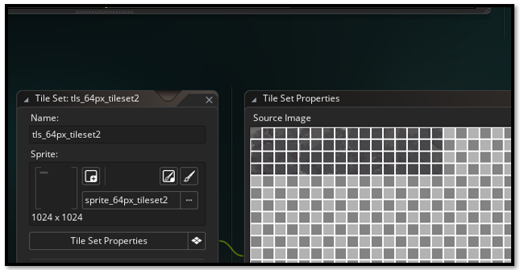
Looking in the left panel, for this tile set, I notice that Game Maker mis interpreted the size of my tiles. I had tiles that were sized at 64 px, and yet for this tile set, Game Maker is saying that my tiles are 16px X 16px. So, I need to change this.
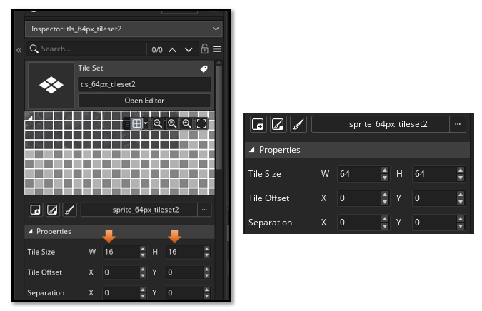
And now our floor tiles look how they are supposed to look.
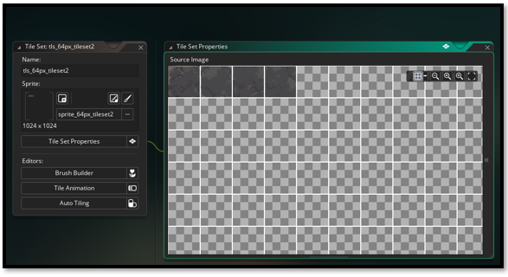

Create your door image


64 X 64
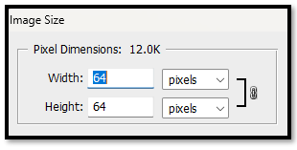
Now save it to the sprite folder
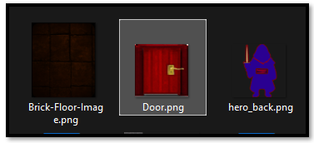

Door Sprite
Now you need to create the door sprite.
Right click on the sprite folder to create the sprite. And give it the image of the door.
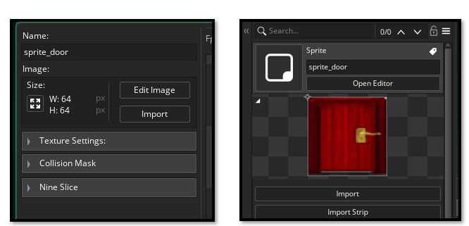

Create the Door Object
Now that the door sprite is created, create the door object.
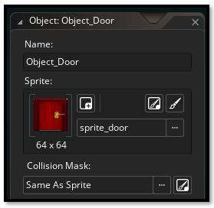

Create a New Room
Right click on the room folder, and create another room.
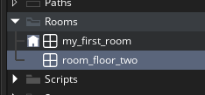
Make sure that your dimensions are set to 1344 X 768, or things will be off. You can of course make a new size for the room, but it needs to fit our grid size of 64 X 64, so for now it might just be easier to keep the room at 1344 X 768.

Changing the Grid spacing
Click the down arrow next to the grid icon to get to options for the room grid. Then just change the dimensions for this room to be 64 X 64 for the grid settings.
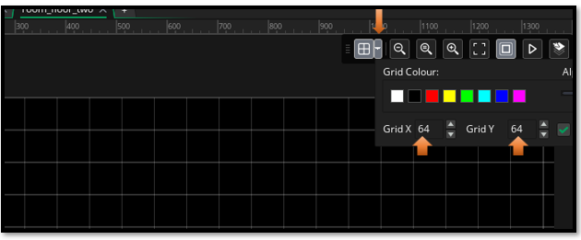

Create the Floor_Tile Layer
You will find that since you are on a new floor, you will need to recreate, your Layers inside of the room
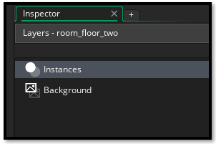
Now create a new tile layer for the floor.

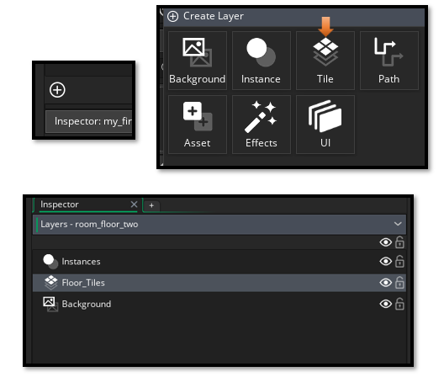
Note, Don’t worry about the grid size changing back to 32, this will change back as soon as you select your tile set which is set to 64px. We select the tile set next.

On the right-hand side of the app, change to Room Editor tab.
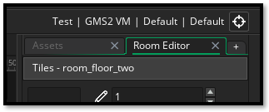
Now select your tileset
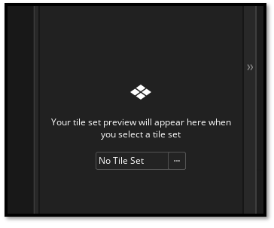
Pull in your floor
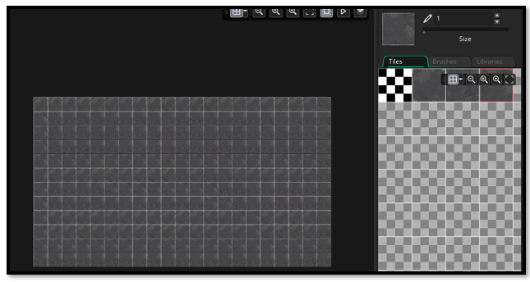

Add a Wall tile layer.

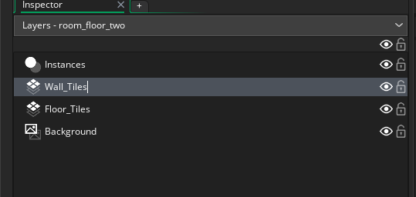
Now place the wall around the edges. The wall object will be your first tile map at 32 px, so choose that one.
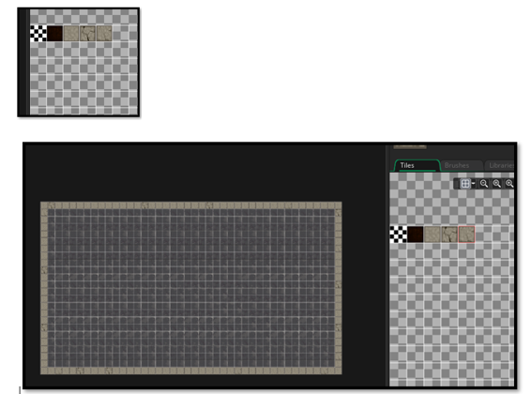

Collision Event with Door.
Place the door object on the same layer as the hero. It is an instance, and any number of instances can share this same instance layer.
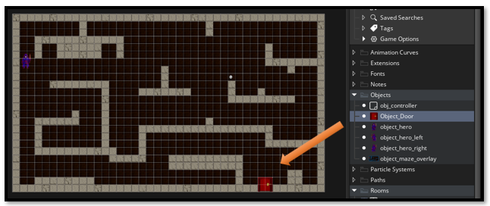

The Door Collision code.
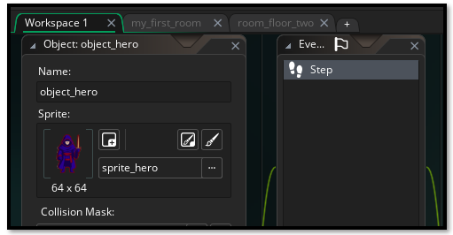

Now in order to go from room 1, to room 2, we need a collision event with the hero object.

if (place_meeting(x, y, Object_Door)) {
room_goto(room_floor_two);
}
In the code, you want to place it in the hero, step event right before the Sprite switching code.
// Movement input
var move_x = keyboard_check(vk_right) - keyboard_check(vk_left);
var move_y = keyboard_check(vk_down) - keyboard_check(vk_up);

var spd = 4;
var dx = move_x * spd;
var dy = move_y * spd;

// --- Attempt full diagonal move first ---
if (dx != 0 || dy != 0) {
var nx_left = bbox_left + dx;
var nx_right = bbox_right + dx;
var ny_top = bbox_top + dy;
var ny_bottom = bbox_bottom+ dy;

var hit_diag =
wall_is_solid(nx_left, ny_top) ||
wall_is_solid(nx_right, ny_top) ||
wall_is_solid(nx_left, ny_bottom) ||
wall_is_solid(nx_right, ny_bottom);

if (!hit_diag) {
// Move freely if no diagonal collision
x += dx;
y += dy;
} else {
// --- If diagonal blocked, try X only ---
var hit_x =
wall_is_solid(bbox_left+dx, bbox_top) ||
wall_is_solid(bbox_right+dx, bbox_top) ||
wall_is_solid(bbox_left+dx, bbox_bottom) ||
wall_is_solid(bbox_right+dx, bbox_bottom);

if (!hit_x) {
x += dx;
}

// --- Then try Y only ---
var hit_y =
wall_is_solid(bbox_left, bbox_top+dy) ||
wall_is_solid(bbox_right, bbox_top+dy) ||
wall_is_solid(bbox_left, bbox_bottom+dy) ||
wall_is_solid(bbox_right, bbox_bottom+dy);

if (!hit_y) {
y += dy;
}
}
}

if (place_meeting(x, y, Object_Door)) {
room_goto(room_floor_two);
}

// --- Sprite switching ---
if (move_y < 0) sprite_index = sprite_hero_back;
else if (move_x > 0) sprite_index = sprite_hero_right;
else if (move_x < 0) sprite_index = sprite_hero_left;
else sprite_index = sprite_hero;

